 | University of Management & Technology  Department of Computer Science  School of Systems and Technology  Fall Semester 2025
 |  | Dr. Asfaq Ahmad |  | Design
Instructor’s Name: |  | Syed Hamed Raza | Subject: | Discrete Structures
Date: |  | 18-11-2025 | Subject Code:
Quiz #: |  | 1 | Total Marks: | 20
Student Name: |  |  | Reg #:
Time Allowed: |  | 45 Minutes
Instructions for Candidates
Read the instructions carefully.
- Write Question number and its part number clearly.
- Attempt all questions.
- Cutting or over-writing is not acceptable
- Illustrate your answers with diagrams, graphs and tables if required.
- Cross off blank pages before handing over the Answer-book to the examination staff at completion of the examination.

Q1.
Define the set
A = {2, 4, 8, 16, 32, 64}.
- Express A using set-builder notation.
- Determine whether A is infinite or finite, giving justification.
Solution:
- Set-builder form:
$$A=\{ 2^{k}∣k∈Z, 1≤k≤6 \}.$$
(Equivalent: $A=\{2^{k}∣k∈\{1,2,3,4,5,6\}\}$.)
- Finite because there are exactly 6 elements, so $∣A∣=6$.

Q2.
Let S = {∅, {a}, {a, b}}.
- List all elements of P(S).
- Compute |P(P(S))|.
- Explain why the empty set ∅ and {∅} are distinct elements in this context.
Solution:
Given $S=\{∅,\{a\},\{a,b\}\}$. Note $∣S∣=3$.
- $P(S)$(list of all subsets of $S$). There are $2^{3}=8$ elements:
P(S) = {∅,
{∅}, {{a}}, {{a,b}},
{∅, {a}}, {∅, {a,b}}, {{a}, {a,b}},
{∅, {a}, {a,b}}}
- |P(P(S))| = 2^|P(S)| = 2^8 = 256.
- They differ because $∅$ contains 0 elements while $\{∅\}$contains 1 element.
Q3.
Let
U = {1,2,3,4,5,6,7,8,9},
A = {1,3,4,7},
B = {2,3,5,7,8},
C = {1,2,3,6}.
Compute each expression carefully:
a) (A ∩ B) ∪ (B − C)
b) (A Δ B) − C
c) (Aᶜ ∩ Bᶜ) ∪ C
Solution:
a)
$A∩B=\{3,7\}$.
$B-C=\{5,7,8\}$.
$\left(A ∩ B\right)∪ \left(B - C\right)= \{3,7\}∪\{5,7,8\}=\{3,5,7,8\}.$
b)
$A∩B=\{3,7\}$.
$AΔB=(A∪B)∖(A∩B)=\{1,2,4,5,8\}$.
$\left(A Δ B\right)- C= \{4,5,8\}$.
c)
$A^{c}=U∖A=\{2,5,6,8,9\}$.
$B^{c}=U∖B=\{1,4,6,9\}$.
$A^{c}∩B^{c}=\{6,9\}$.
$\left(Aᶜ ∩ Bᶜ\right)∪ C=\{1,2,3,6,9\}$.

Q4.
In a survey of 100 students:
• 40 used software A
• 55 used software B
• 30 used software C
• 20 used both A and B
• 12 used both B and C
• 10 used both A and C
• 7 used all three
- Draw a correct 3-set Venn diagram
- Determine how many students used none of the software packages.
- Determine how many students used exactly one software package.
Solution:
Given (100 students):
$$∣A∣=40, ∣B∣=55, ∣C∣=30$$$∣A∩B∣=20, ∣B∩C∣=12, ∣A∩C∣=10, ∣A∩B∩C∣=7$.

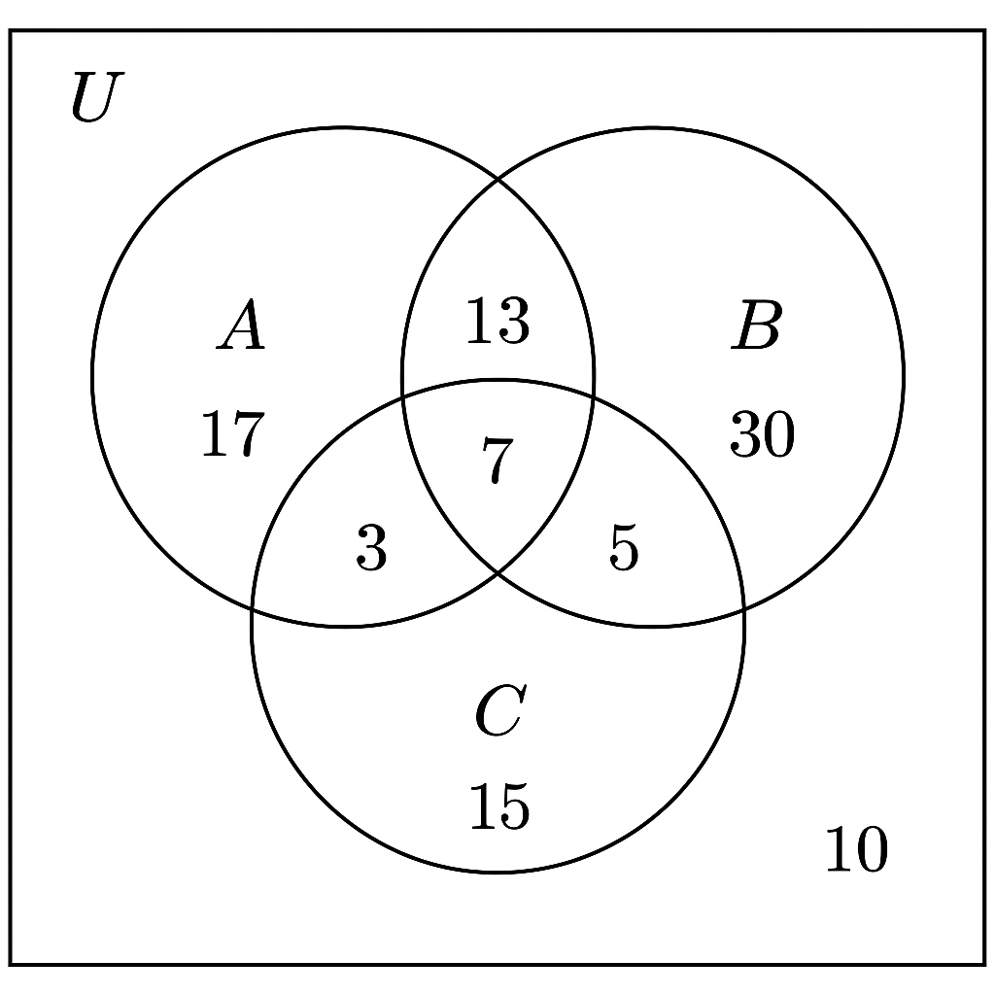
- Number using at least one package by inclusion exclusion:
$$∣A∪B∪C∣=∣A∣+∣B∣+∣C∣-(∣A∩B∣+∣A∩C∣+∣B∩C∣)+∣A∩B∩C∣$$
Plug in: $125-42+7=90$.
Hence none = $100-90=10$.
- Number using exactly one package. Use region formula:
- $A_{\text{only}}=∣A∣-∣A∩B∣-∣A∩C∣+∣A∩B∩C∣=40-20-10+7=17.$
- $B_{\text{only}}=55-20-12+7=30.$
- $C_{\text{only}}=30-12-10+7=15.$
Exactly one total = $17+30+15=62.$
Answers: none = 10; exactly one = 62.

Q5.
A sequence is defined by
aₙ = (−1)ⁿ n² + 3n.
- Compute a₀ through a₅.
Solution:
Given $a_{n}=(-1)^{n}n^{2}+3n$.
- Compute $a_{0}$through $a_{5}$:
$$a_{0}=(+1)⋅0^{2}+0=0.$$
$$a_{1}=(-1)⋅1^{2}+3=-1+3=2.$$
$$a_{2}=(+1)⋅4+6=10.$$
$$a_{3}=(-1)⋅9+9=0.$$
$$a_{4}=(+1)⋅16+12=28.$$
$$a_{5}=(-1)⋅25+15=-10.$$
So sequence: 0, 2, 10, 0, 28, −10, …

Q6.
Consider the sequence:
3, 9, 27, 81, …
- Prove formally that this sequence cannot be an arithmetic sequence.
- Derive its explicit geometric formula.
Solution:
Sequence: $3,9,27,81,…$
- Not arithmetic sequence: Differences are $9-3=6, 27-9=18, 81-27=54$. Differences are not constant → sequence cannot be arithmetic.
- Geometric formula: common ratio $r=3$. If we index $a_{1}=3$, then $a_{n}=3^{n}$for $n≥1$.
Q7.
Evaluate the sum:
$$\sum_{k=1}^{n}{}(4k-1)$$
Then:
- Simplify your final expression into a closed-form polynomial in n.
- Evaluate the case n = 75.
- Explain why this summation must yield an arithmetic series, referring to common difference.
Solution:
Compute using linearity:
$$\sum_{k=1}^{n}{}(4k-1)=4\sum_{k=1}^{n}{}k-\sum_{k=1}^{n}{}1=4⋅\frac{n(n+1)}{2}-n=2n(n+1)-n=2n^{2}+n.$$
- Closed form: $2n^{2}+n$.
- For $n=75$: $2(75)^{2}+75=2⋅5625+75=11250+75=11325.$
- Why arithmetic series: The sequence of terms $(4k-1)$as $k$increments increases by constant difference $4$(common difference $d=4$), hence the finite sum is an arithmetic series.

Q8.
A sequence satisfies the recurrence:
aₙ = 4aₙ₋₁ − 4aₙ₋₂, for n ≥ 2,
with initial conditions:
a₀ = 1, a₁ = 6.
- Compute a₂, a₃, a₄.
Solution:
Recurrence: $a_{n}=4a_{n-1}-4a_{n-2}$, $a_{0}=1, a_{1}=6$.
Compute successive terms:
$$a_{2}=4a_{1}-4a_{0}=4⋅6-4⋅1=24-4=20.$$
$$a_{3}=4a_{2}-4a_{1}=4⋅20-4⋅6=80-24=56.$$
$$a_{4}=4a_{3}-4a_{2}=4⋅56-4⋅20=224-80=144.$$
So $a_{0}=1, a_{1}=6, a_{2}=20, a_{3}=56, a_{4}=144.$

